**TED Talks**

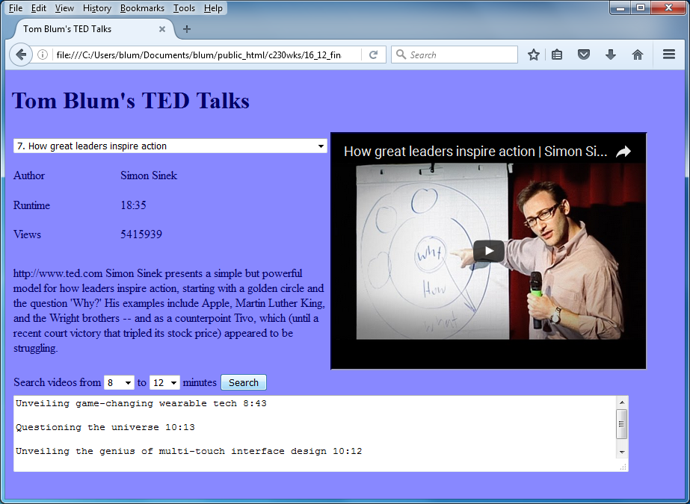

1. Use TED_start.html, give it a title John Smith’s TED Talks (with John Smith replaced by your name).
2. Add an HTML comment with your name.
3. The background color and font color should be anything other than the default values.
4. Put a header at the top of the page reading John Smith’s TED Talks (with John Smith replaced by your name).
5. Using the format provided, add elements to complete a design like that shown above

|  |  |  |
| --- | --- | --- |
| 1. **Select** | | 1. **iframe** |
| Author | **C.** |
| Runtime | **D.** |
| Views | **E.** |
| F. | |
| **G. Select select button** | | |
| **H. Textarea** | | |

1. The Cell A should have a drop-down select for the TedTalk Rank and Title. No blank option.
2. Cell B should contain an iframe of width 420px and height 315px.
3. Cell C is for the author; Cell D for the (run)time; Cell E for the number of views; Cell F (with the id of spDesc should have a height of 160px and is for the description.)
4. Cell G has two drop-down selects with options 4, 8, … 24. Cell G should also have a button.
5. Cell H has a textarea (cols: 100, rows: 5 and be readonly)
6. Start a script area and place a comment with your name at the top.
7. Make a JavaScript class having the following properties: tedRank, tedTitle, tedAuthor, tedTime, tedViews, tedDesc, and tedYoutube.
8. When the page starts, fetch the ted.txt file and create an array of objects of the class you made.
9. Then populate the drop-down select with a concatenation of the rank and title of the TED talks. There should be no blank option.
10. Either in design or code, the page should start with the Number 1 ranked TED talk.
11. Have code that will clear out the search textarea when the page is refreshed.
12. When the user selects an item from the drop-down select, display the Author, Runtime, Number of Views, and Description.
13. Also have the corresponding youtube video embedded into the iframe. Concatenate the literal <https://www.youtube.com/embed/> and the youtube code and set the src property of the iframe.

<iframe width="420" height="315"  
src="https://www.youtube.com/embed/XGSy3_Czz8k">  
</iframe>

(https://www.w3schools.com/html/html_youtube.asp)

1. When the user clicks the button, determine the Low and High numbers from the dropdown selects. If you use parseInt() on the (run)time property, you should have just the minutes. Loop through the videos, and pick out videos with minutes that are greater than or equal to the Low number and less than the High number. Each result should have the video title and time and be on its own line and separated from the previous result by a blank line.
2. If either the low or high drop-down select is changed, then clear out the search results.

https://www.youtube.com/playlist?list=PL70DEC2B0568B5469